VZ SUPER GRAPHICS PART II BY JOE LEON
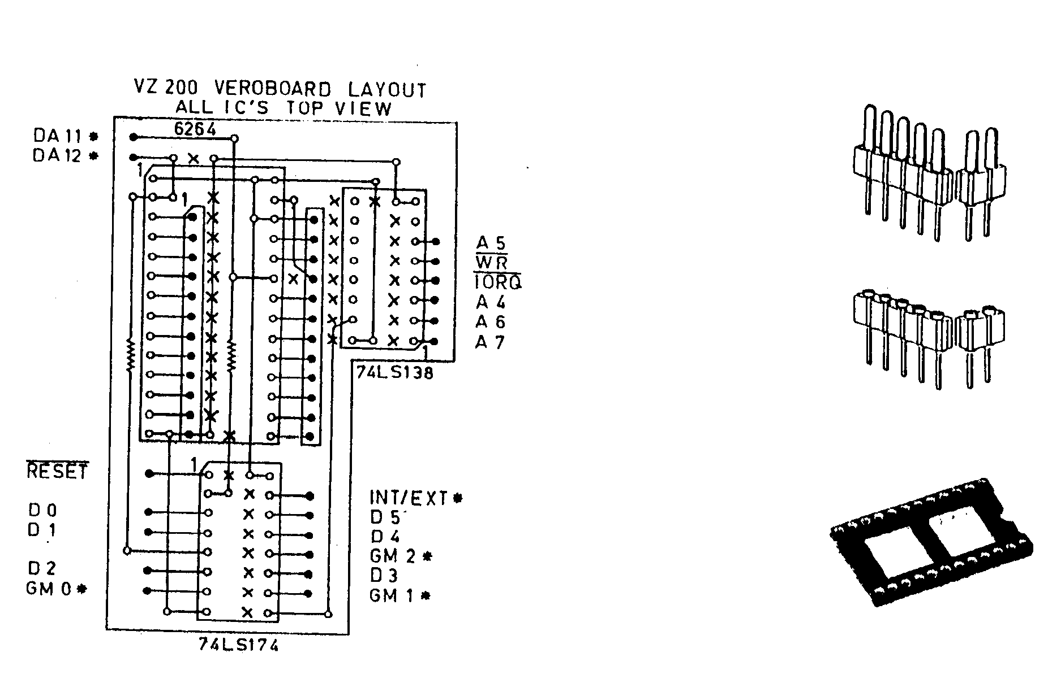
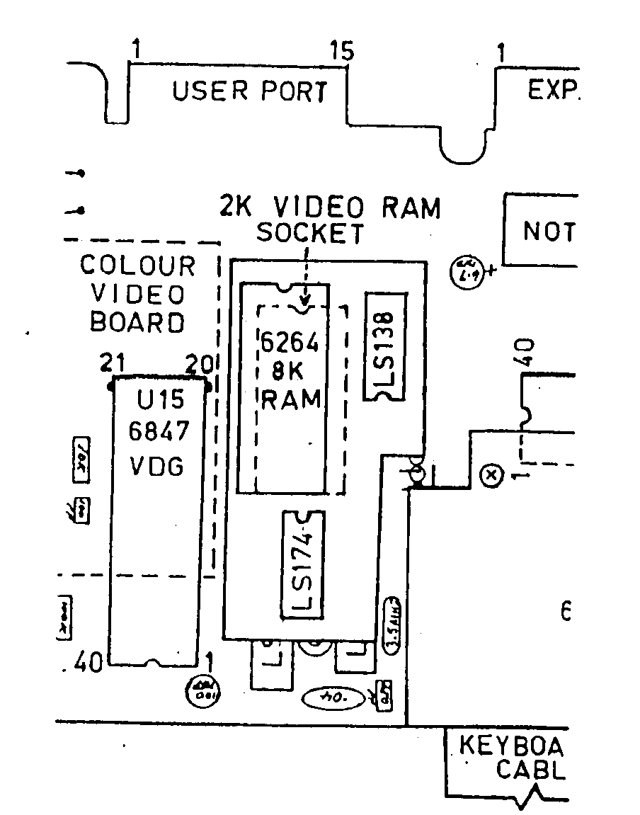
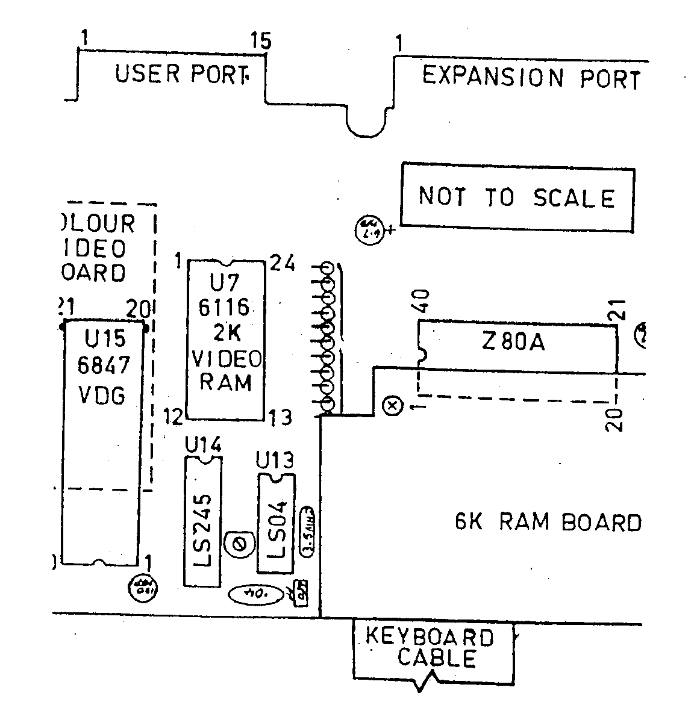
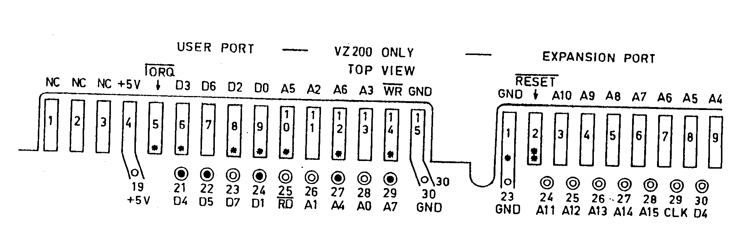
VZ SUPER GRAPHICS PART II CONT. ...........17
PLEASE READ DISCLAIMER ON BOTTOM OFF PAGE 5 BEFORE ATTEMPTING THIS PROJECT.
NOTE - VZ SUPER GRAPHICS ISSUE # 22 -the parts LIST FOR SUPER GRAPHICS was ACCIDENTALLY LEFT OUT AND IS REPRODUCED HERE FOR BOTH VZ 200 & VZ 300.
1 X 74LS138
1 X 74LS174
1 X 6264 8K ram
2 X 6K8 resistors
1 X 0.1 ceramic oR MONOLITHIC CAPACITOR
1 X 24 PIN M/I (machine insert) socKET
1 X 32-50 PIN M/I SOCKET STRIP (VZ 200).
1 X 32 PIN M/I ADAPTOR STRIP
1 X 40 PIN M/I SOCKET (VZ 300)
1 X 40 WAY IDC FLAT RIBBON CABLE DIL PLUG (VZ 300).
1 X miniature push button switch
19 X 15CM (6") LENGTHS OF INSULATED HOOK UP WIRE
1 piece of VEROBOARD 17 holes accross by 19 tracks down (VZ 300).
1 piece of VEROBOARD 16 holes accross BY 25 tracks down (VZ 200).
NOTE - on PAGE 16, TOP RIGHT ARE DEPICTED M/I (machine insert) aDAPTOR STRIP, M/I SOCKET STRIP & 24 PIN M/I SOCKET.
PREPARING VZ 200 - first taKE VZ CASE APART AND REMOVE CIRCUIT BOARD FROM CASE. next REMOVE RF SHIELD BY UNSOLDERING IT FROM PCB.
6116 - unsolder 2K VIDEO RAM OR CUT PINS ON ONE SIDE AND LEVER BACK AND FORTH TILL PINS BREAK ON OTHER SIDE. remove PIN STUBS AND INSPECT BOARD FOR DAMAGE AND REPAIR IF NEEDED. next soLDER A 24 PIN M/I SOCKET IN 6116'S PLACE.
6847 (VDG) - remove TWO SCREWS ON COLOUR VIDEO BOARD AND LIFT BOARD UP OUT OF ROAD SO YOU HAVE ACCESS TO 6847. using sMALL SIDECUTTERS CUT THE FOLLOWING PINS AS CLOSE TO THE PCB AS POSSIBLE AND BEND UP 90 DEG. cut PINS 27, 29 & 30 ON 6847 AND BEND UP 90 DEG. do NOT FORGET TO REMOVE PIN STUBS FROM PCB.
PREPARING VZ 200 PLUG IN MODULE :-
VEROBOARD - the tRACKS RUN HORIZONTALLY, FROM LEFT TO RIGHT. open aND SOLID CIRCLES DENOTE USED HOLES ON VEROBOARD. vertical LINES DENOTE INSULATED LINK WIRES. horizontal LINES SIMPLY DENOTE USED TRACKS AND ARE SHOWN FOR CLARITY ONLY. the (X'S) DENOTE CUT TRACKS.
using aN 1 /8" (3MM) DRILL BIT CUT TRACKS MARKED WITH AN (X) CHECKING AND DOUBLE CHECKING ALL ARE CORRECT AND HAVE 'NT MISSED ANY. next INSERT ALL LINK WIRES. please NOTE LINK WIRE UNDER 6264, PIN 26 HAVE TWO WIRE LINK ENDS GOING INTO SAME HOLE.
mount tHE RESISTOR ON THE LEFT NEXT. the RESISTOR SHOWN UNDER 6264 IC IS MOUNTED UNDER THE BOARD WITH ONE END SHARING HOLE WITH LINK WIRE. be CAREFULL NOT TO SHORT OUT TRACKS UNDERNEATH.
M/I adaptor stRIP - this IS A DOUBLE SIDED SINGLE ROW OF PINS WHICH CAN BE SNAPPED TO DESIRED LENGTH. one sIDE HAS THINNER PINS THAN OTHER SIDE. snap TWO LENGTHS OF 12 PINS EACH. insert tHE STRIPS IN THE 24 PIN RAM SOCKET WITH THINNER PINS AT BOTTOM.
next PUT VEROBOARD ON TOP OF PINS AND LOWER DOWN ON THEM. LIFT V/BOARD UP TILL IT JUST CLEARS COMPONENTS ON PCB AND MARK HEIGHT ON PINS. remove PINS FROM SOCKET AND SOLDER THICK PINS TO V/BOARD TO MARKED HEIGHT AND CUT ALL PINS ON LEFT STRIP FLUSH WITH TOP OF V/BOARD.
the RIGHT ADAPTOR STRIP NEED NOT BE CUT PLUSH AS A LINK WIRE IS SOLDERED TO ONE PIN. the two stRIPS ON V/BOARD LAYOUT MARKED WITH SOLID CIRCLES IS WHERE THE ADAPTOR STRIPS ARE SOLDERED TO.
VZ SUPER GRAPHICS PART II CONT. ...........18
before PROCEEDING FURTHER TRY PLUGGING IN MODULE INTO 2K VIDEO RAM SOCKET TO CHECK IF IT PLUGS IN PROPERLY AND CLEARS ALL COMPONENTS AND REMOVE. using NO SOCKETS SOLDER THE 74LS174, 74LS138 & 6264 IC'S IN NEXT MAKING SURE THE IC'S ARE SOLDERED IN RIGHT WAY ROUND. using tHE V/BOARD LAYOUT AS A GUIDE SOLDER ALL 19 OFF BOARD LINK WIRES.
using BIT OF THIN CARDBOARD LIKE FROM BACK OF WRITING PAD CUT A PIECE BIT LARGER THAN V/BOARD. cut two sLOTS FOR THE TWO ADAPTOR STRIPS TO GO THROUGH AND INSERT C/BOARD UNDER BOARD WHICH IS USED TO INSULATE BOTTOM OF V/BOARD FROM COMPONENTS IN VZ.
plug IN MODULE IN VACANT 2K VIDEO RAM SOCKET AND SOLDER THE 5 WIRES TO 6847 FIRST WHICH ARE DENOTED BY ASTERISKS. pins 20 & 21 ON PCB ARE NOT CONNECTED TO ANYTHING AND FOR THAT REASON THEY DO NOT HAVE TO BE CUT AND CAN BE SOLDERED TO DIRECT.
the REST OF THE WIRES CAN BE SOLDERED DIRECTLY TO FINGERS ON USER PORT. if yoU CAN GET SINGLE STRAND SHIELDED WIRE THEN YOU COULD SOLDER ONE END TO MODULE AND SOLDER M/I SOCKET STRIPS TO USER PORT AND PLUGGING OTHER END INTO STRIP. this aPPROACH SAVES A LOT OF SOLDERING AND IN CASE OF WIRING ERRORS ARE SIMPLY RECTIFIED. the USER PORT PINOUT IS MARKED BY ASTERISKS FOR SIGNALS NEEDED BY MODULE.
the saME APPROACH CAN BE USED ON 6847 BY SOLDERING M/I SOCKET STRIP/S TO pins 20, 21, 27, 29 & 30 and plugging wires into them.
NOTE - if yoUR VZ 200 HAS AN ETI 687 34K RAM BOARD INSTALLED THEN ONE CORNER OFF IT'S PCB WILL HAVE TO BE CUT AWAY SO MODULE CAN BE PLUGGED IN.
RESET BUTTON - solder 2 wIDE 11/1 SOCKET TO PINS 1 & 2 ON EXPANSION PORT AND THEN SOLDER TWO LENGTHS OF WIRE TO PB SWITCH AND OTHER ENDS TO ANOTHER 2 WIDE M/I SOCKET. this gIVES YOU A PLUG IN RESET BUTTON. you coULD MOUNT RESET BUTTON ON BOTTOM RIGHT LIP OF CASE ABOVE POWER SWITCH.
. if yoUR WORK CHECKS OUT OK THEN REASSEMBLE VZ. the RF SHIELD COULD BE LEFT OFF UNLESS YOU LIVE NEAR A POWER STATION. in tHAT CASE CUT HOLE IN SHIELD IF MODULE TOO HIGH AND RESOLDER TO PCB.
WHENEVER YOU POWER UP OR RESET THE VZ TYPE IN OUT 52,8 AND PRESS RETURN OR YOU'LL END UP WITH ONLY 1K (1024 BYTES) FOR HI-RES SCREENS. it's a gooD IDEA TO INCLUDE AN OUT 52,8 AT START IN ALL YOUR PROGRAMS.
TESTING - refer to ISSUE # 22 CAPTURING HI/LO-RES SCREENS :-
with sUPER GRAPHICS AND RESET BUTTON INSTALLED IN YOUR VZ IT BECOMES A SIMPLE MATTER TO CAPTURE ANY HI/LO-RES SCREEN FROM ANY PROGRAM. simply LOAD YOUR PROGRAM INTO MIDDLE PAGE USING FOLLOWING METHOD :-
OUT32,25:MODE(1):BRUN"INVADERS"
what wE HAVE DONE IS TO SELECT PAGE 1 (MIDDLE PAGE), GRAPHICS MODE (6) AND THEN RUN PROGRAM. it's IMPORTANT TO DO IT AS DESCRIBED ABOVE BECAUSE ONCE YOU SELECT PAGE 1 YOU CAN'T SEE WHAT YOU'RE ENTERING ON SCREEN. once yoUR PROGRAM HAS LOADED IT WILL BE DISPLAYED IN PAGE 1, BUT WON'T LOOK NORMAL.
press RESET BUTTON WHEN DESIRED SCREEN APPEARS. the VZ WILL BE RESET AND AS WILL BE video RAM TO PAGE 0. desired scREEN WILL BE SAFE AND SOUND IN PAGE ONE. in NEXT ISSUE I'LL DESCRIBE HOW' IT CAN BE RETRIEVED FROM PAGE 1.

